Task 2 - Llama3 다운로드
Created: 2025-03-24 (Mon)
Updated: 2025-03-26 (Wed)

요약
Vertex AI Workbench Instance의 디폴트 디스크 사이즈 사용 시 에러 발생
-> 디스크 사이즈를 500GB로 지정

블로그 명령어를 변경
$ sudo apt update && sudo apt install -y python3-pip vllm ray

개발자 유미 > 2. Llama3 다운로드 > 내용 요약

LLM
vLLM이 지원하는 LLMs
https://docs.vllm.ai/en/latest/models/supported_models.html

Llama3.1
Llama-3.1-8B-Instruct https://huggingface.co/meta-llama/Llama-3.1-8B-Instruct

모델 사용 신청 : Hugging face
Huggung face 로그인
Llama-3.1-8B-Instruct 모델 검색
Expand to review access 탭 선택 후 펼치기
개인정보 입력
your settings 클릭
사용 허가 까지 대기
- Request Status 상태가 ACCEPT로 변경되기 까지 약 10분 이상이 소요됩니다.

접근 토큰 발급 받기
프로필 > Settings 클릭
Access Tokens > 토큰 생성
Read 타입 토큰 생성
- 간단하게 별칭을 지은 후 Create token을 선택하면 팝업창으로 토큰값을 확인할 수 있습니다. 이를 복사하여 기록해두시면 됩니다.

핸즈온

HuggingFace 계정을 만든 후 Token을 생성한다.
https://huggingface.co

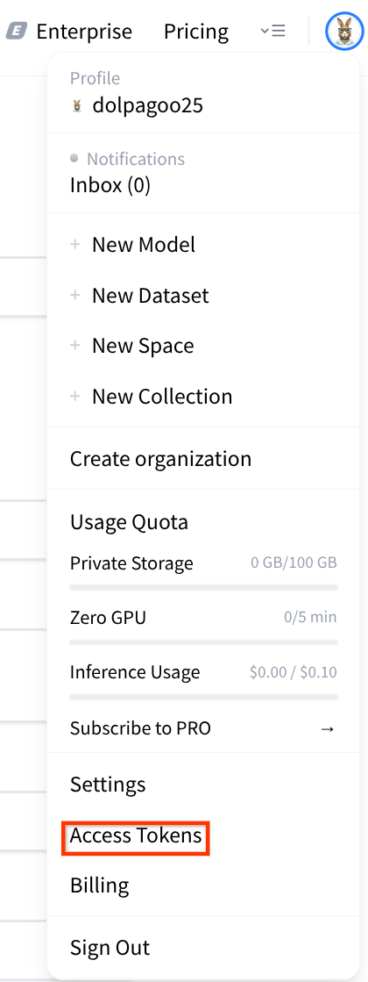

Create new token을 클릭한다.
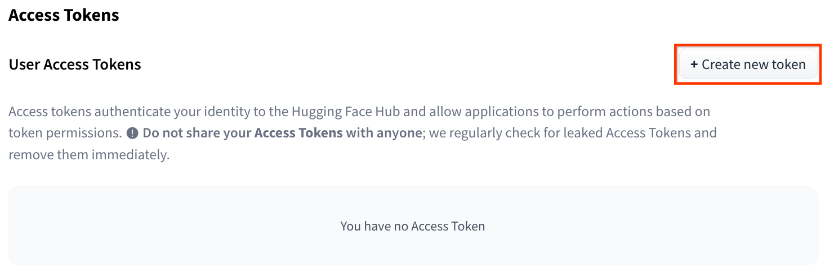

READ를 클릭하고, Token name에 값을 입력 후, Create token을 클릭한다.
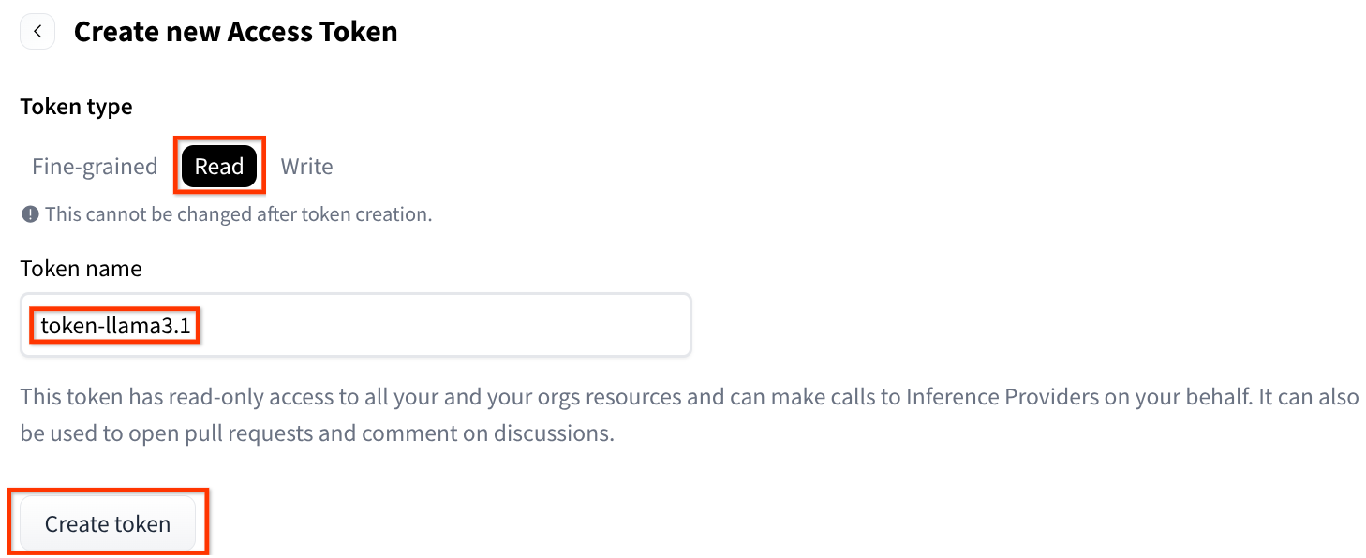

팝업창에 생성된 Token의 값을 복사 후, 별도 장소에 잘 보관한다.

아래처럼 생성되었음을 알 수 있다.
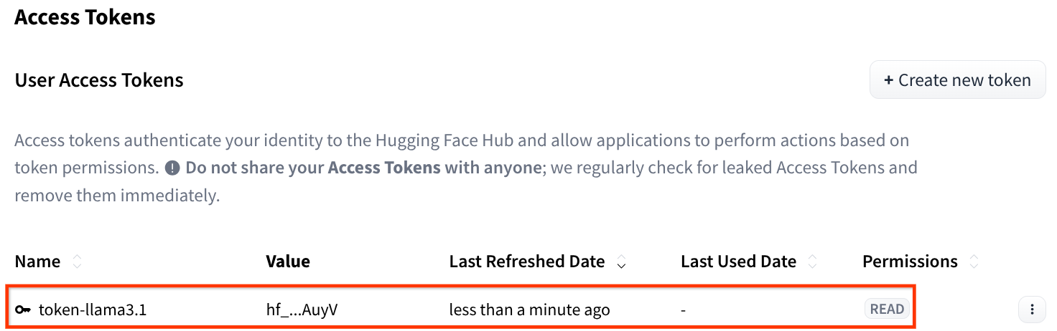

Llama-3.1-8B-Instruct
https://huggingface.co/meta-llama/Llama-3.1-8B-Instruct에 접속한다.

상단에 Expand to review and access를 클릭하고, 아래까지 스크롤 다운 한다.

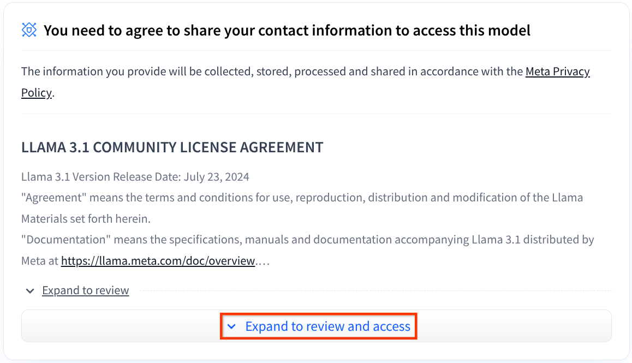

요청받은 값을 입력 후 Submit을 클릭하면 상태가 아래처럼 변경
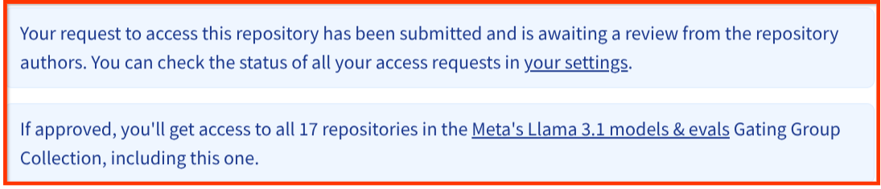

확인 메일이 발송되면 완료
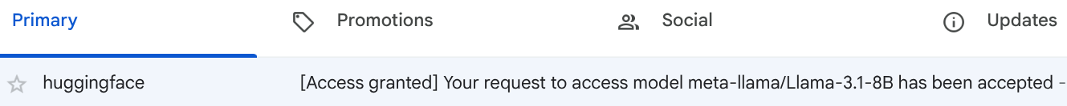

VM에서 실행
$ sudo apt update
$ sudo apt install -y git-lfs
주의: 기존에 git이 설치되어 있다고 하더라도 대용량 리포지토리 다운로드를 위한 git-lfs가 아니기 때문에 git-lfs를 설치해야 합니다.

Hugging face 아이디 입력과 접속 토큰 (비밀번호 아님) 입력 항목이 발생합니다.
$ mkdir my_model
$ cd my_model
$ git clone https://huggingface.co/meta-llama/Meta-Llama-3.1-8B-Instruct

(base) jupyter@tkim-instance-l4gpu-vllm-test:~$ mkdir my_model
(base) jupyter@tkim-instance-l4gpu-vllm-test:~$ cd my_model/
(base) jupyter@tkim-instance-l4gpu-vllm-test:~/my_model$ git clone https://huggingface.co/meta-llama/Meta-Llama-3.1-8B-Instruct

Cloning into 'Meta-Llama-3.1-8B-Instruct'...
Username for 'https://huggingface.co': dolpagoo25
Password for 'https://dolpagoo25@huggingface.co':
remote: Enumerating objects: 109, done.
remote: Counting objects: 100% (106/106), done.
remote: Compressing objects: 100% (106/106), done.
remote: Total 109 (delta 53), reused 0 (delta 0), pack-reused 3 (from 1)
Receiving objects: 100% (109/109), 2.28 MiB | 19.64 MiB/s, done.
Resolving deltas: 100% (53/53), done.
Username for 'https://huggingface.co': dolpagoo25
Password for 'https://dolpagoo25@huggingface.co':
Filtering content: 100% (6/6), 5.91 GiB | 35.26 MiB/s, done.
Encountered 4 file(s) that may not have been copied correctly on Windows:
model-00003-of-00004.safetensors
model-00001-of-00004.safetensors
model-00002-of-00004.safetensors
original/consolidated.00.pth

See: `git lfs help smudge` for more details.
(base) jupyter@tkim-instance-l4gpu-vllm-test:~/my_model$

용량이 크기 때문에 어느정도 시간이 소요됩니다.

부록. T4 GPU를 사용했을 때 겪은 에러
결론은 T4 GPU는 사용이 불가능하고 L4 GPU를 써야한다는 것이지만 참고용으로 첨부함

Problem. 다운로드 불가능
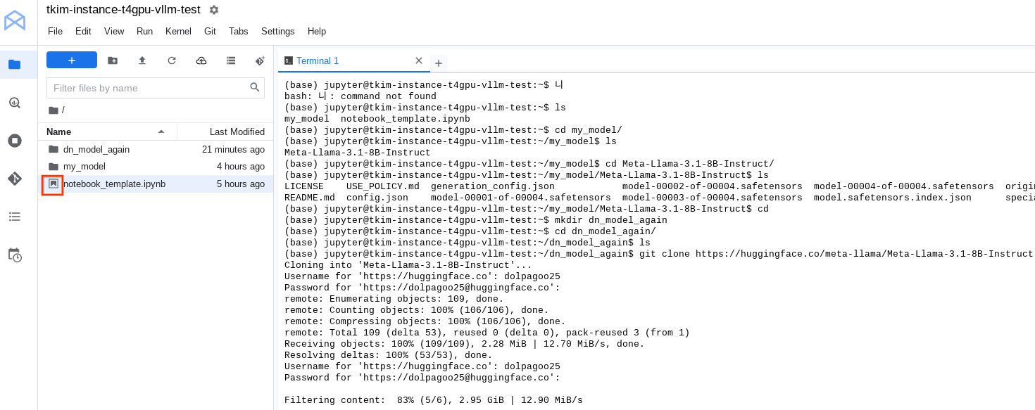
시스템이 Hang걸린 듯…
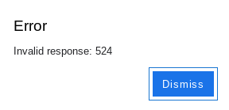

Hint 1. 다운로드 재시도
아래 제안처럼 재시도 했지만 여전히 동일한 문제가 발생. Why?
$ cd
$ mkdir dn_model_again
$ cd dn_model_again
$ git clone https://huggingface.co/meta-llama/Meta-Llama-3.1-8B-Instruct

I'm using a Vertex AI Workbench Instance and I was downloading an LLM model from HuggingFace.

$ mkdir my_model
$ cd my_model
$ git clone https://huggingface.co/meta-llama/Meta-Llama-3.1-8B-Instruct

The download not only stopped, but also caused an error in a JupyterLab.

Error
Invalid response: 524

What's wrong? How can I fix it?
The "Invalid response: 524" error you're encountering during the git clone of the Hugging Face model on your Vertex AI Workbench instance indicates a gateway timeout. This error typically means that the server (in this case, Hugging Face's servers) took too long to respond, or didn't respond at all, within the allotted time.

Here's a breakdown of the problem and how to fix it:
Possible Causes:
- Hugging Face Server Overload:
  - Large language models (LLMs) are very popular, and Hugging Face servers can experience heavy traffic, especially when new models are released or during peak usage times.
  - The sheer size of LLM repositories (like Meta-Llama-3.1-8B-Instruct) can also contribute to longer download times, increasing the likelihood of timeouts.
- Network Issues:
  - Temporary network disruptions between your Vertex AI Workbench instance and Hugging Face's servers can lead to timeouts.
  - Firewall or proxy configurations on your Workbench instance or network could also interfere with the connection.
- Vertex AI Workbench Instance Limitations:
  - While less likely, there might be temporary resource limitations on your Workbench instance affecting its ability to sustain a long download.
- Large file size:
  - LLM files can be very large. If the connection is unstable, or the download takes too long, the connection will be terminated.

Solutions:
- Retry the Download:
  - The simplest solution is often to retry the git clone command. Network issues and temporary server overloads are often transient.
  - If the error persists, try again at a time when network traffic might be lower (e.g., off-peak hours).
- Use git lfs clone:
  - Large language models often use Git Large File Storage (LFS) to handle large files. Ensure you have Git LFS installed on your Vertex AI Workbench instance:
sudo apt-get update
sudo apt-get install git-lfs
git lfs install
  - Then retry the clone command.
git lfs clone https://huggingface.co/meta-llama/Meta-Llama-3.1-8B-Instruct
  - Using Git LFS will handle the download of the large model files more efficiently.
- Download Using huggingface_hub (Recommended):
  - The huggingface_hub Python library is designed for interacting with Hugging Face models and datasets. It often provides more robust download capabilities.
  - Install the library:
pip install huggingface_hub
  - Use the snapshot_download function:
from huggingface_hub import snapshot_download

model_name = "meta-llama/Meta-Llama-3.1-8B-Instruct"
local_dir = "my_model"

snapshot_download(repo_id=model_name, local_dir=local_dir)

  - This method generally handles large file downloads more reliably and can resume interrupted downloads. It also bypasses many git related errors.
- Check Network Connectivity:
  - Verify your Vertex AI Workbench instance's internet connection.
  - You can run simple network tests to check for connectivity issues.
ping huggingface.co or
traceroute huggingface.co
- Increase Timeout (Less Recommended):
  - While you can try to increase the Git timeout, this is generally not recommended because it can mask underlying network or server issues. Git itself, and the remote server have timeouts for good reasons.
  - It is much better to use the huggingface_hub library.
- Download in Chunks (Advanced):
  - For extremely large models, you could investigate methods to download the files in smaller chunks, but this is a complex solution and usually not necessary when using huggingface_hub.
In summary, using the huggingface_hub library is the most robust and recommended approach to downloading large models from Hugging Face. It handles large files efficiently and is more resilient to network interruptions.

Hint 2.
JupyterLab이 있는 탭을 닫고,
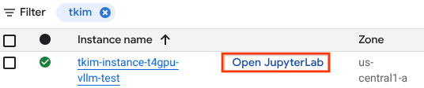
Open JupyterLab을 다시 클릭해도 524 에러가 발생.


Instance name을 클릭한다.
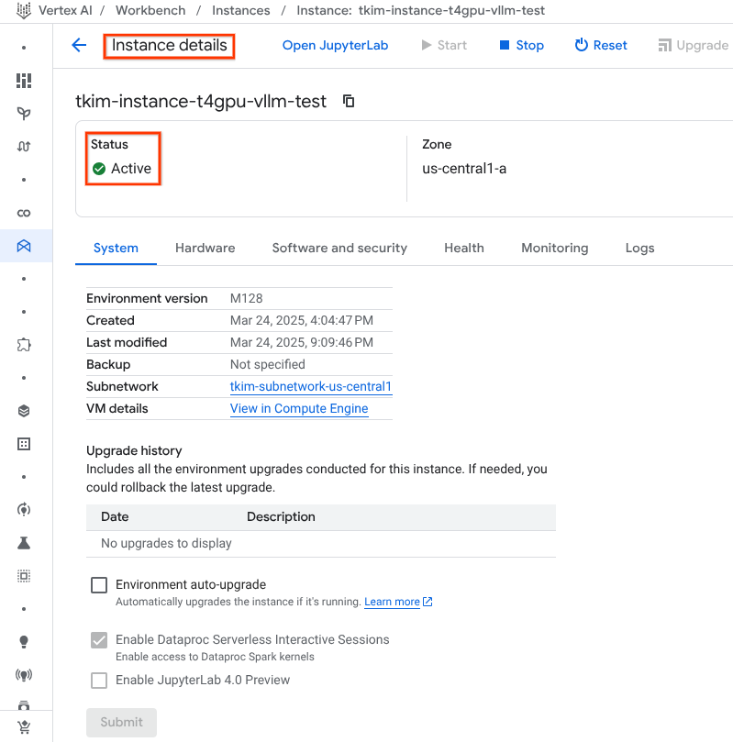

Hardware탭을 클릭한다.
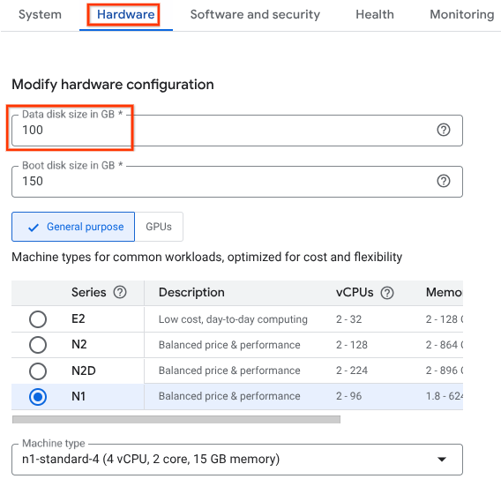
디스크 사이즈가 너무 작아서 생기는 문제인 듯…

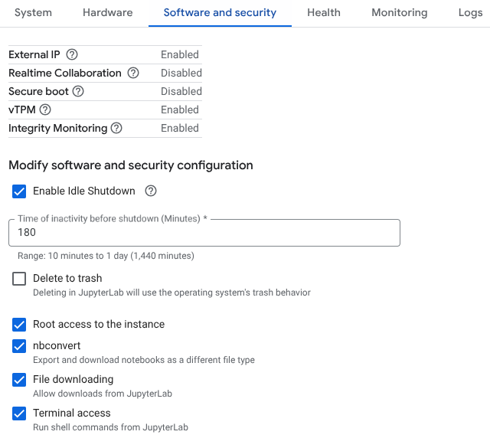
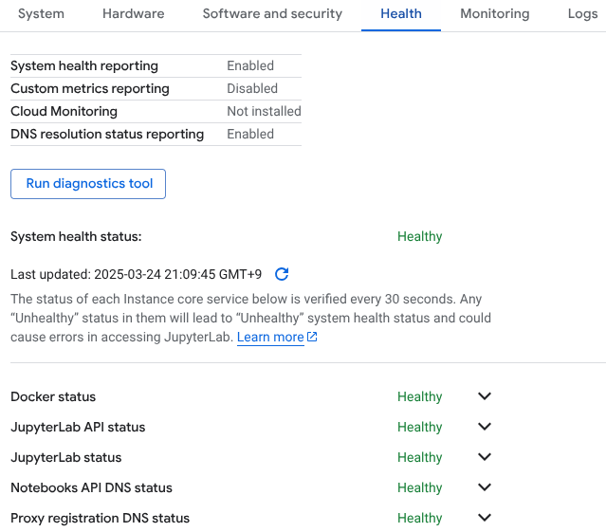

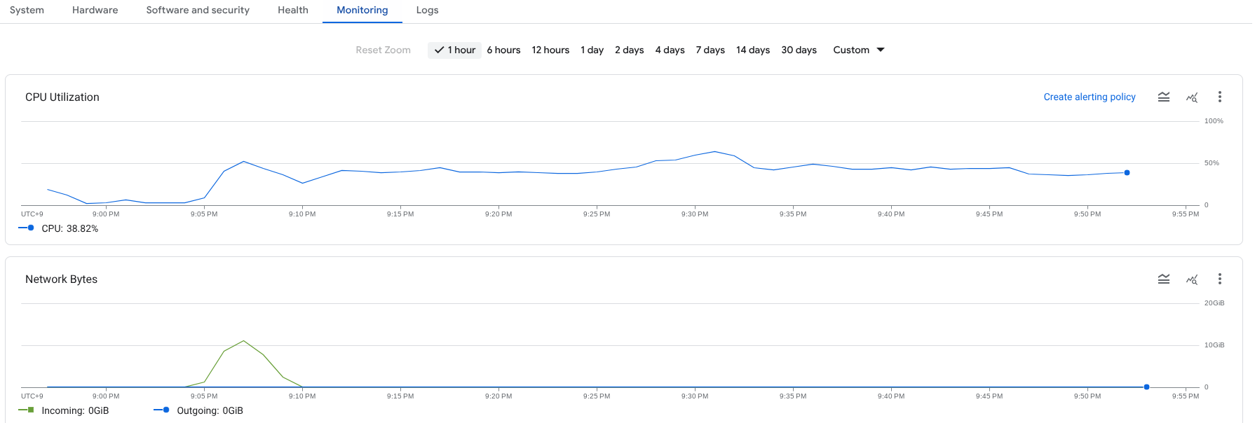

문제 발생!
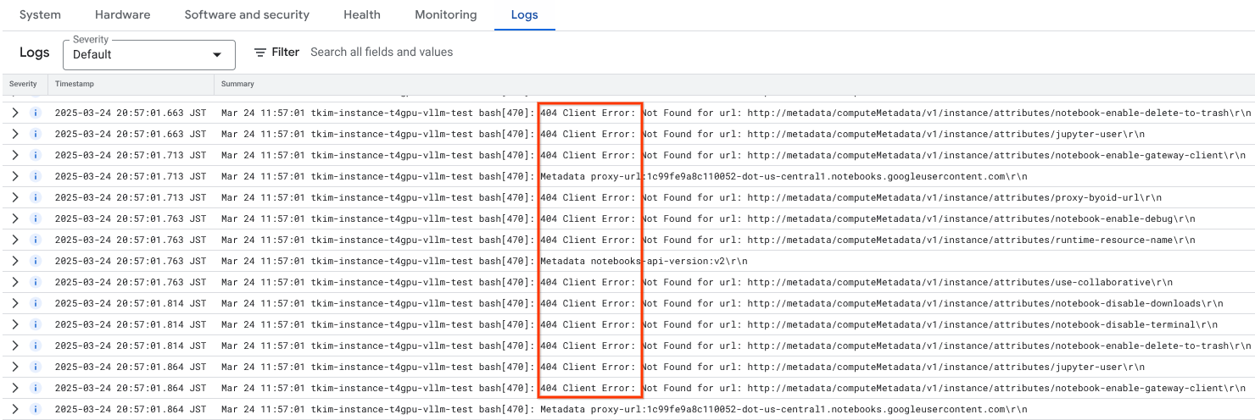

Solution

디스크 사이즈를 500으로 변경한다.
우선 Instance name을 클릭하고, Stop을 클릭한다.
아래처럼 Stop이 되고난 다음,
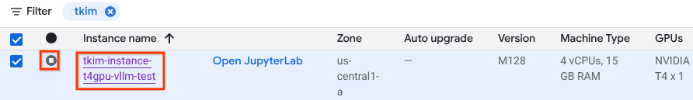

Instance name을 클릭하고
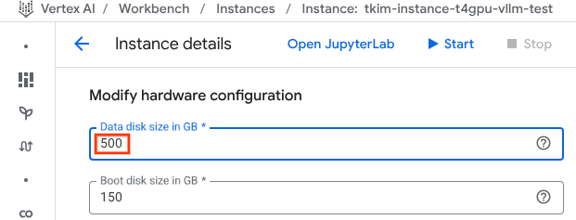

Submit을 클릭한다.

Open JupyterLab을 클릭한다.

문제 해결!
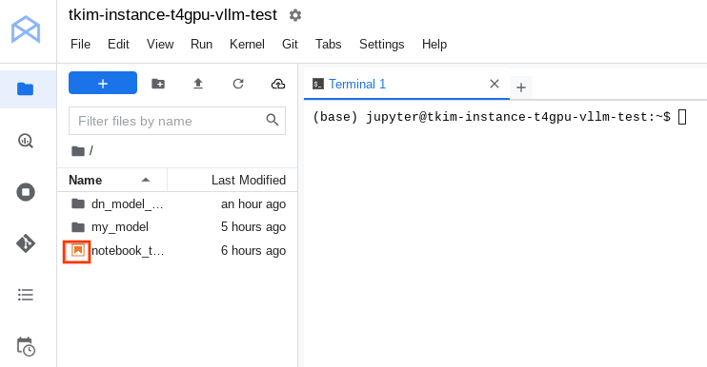
(base) jupyter@tkim-instance-t4gpu-vllm-test:~$ ls
dn_model_again my_model notebook_template.ipynb
(base) jupyter@tkim-instance-t4gpu-vllm-test:~$ cd dn_model_again/
(base) jupyter@tkim-instance-t4gpu-vllm-test:~/dn_model_again$ rm -rf *
(base) jupyter@tkim-instance-t4gpu-vllm-test:~/dn_model_again$ ls -al
total 8
drwxr-xr-x 2 jupyter jupyter 4096 Mar 24 13:07 .
drwxr-xr-x 12 jupyter jupyter 4096 Mar 24 12:04 ..
(base) jupyter@tkim-instance-t4gpu-vllm-test:~/dn_model_again$ cd ..
(base) jupyter@tkim-instance-t4gpu-vllm-test:~$ rmdir dn_model_again/
(base) jupyter@tkim-instance-t4gpu-vllm-test:~$ ls
my_model notebook_template.ipynb
(base) jupyter@tkim-instance-t4gpu-vllm-test:~$ cd my_model/
(base) jupyter@tkim-instance-t4gpu-vllm-test:~/my_model$ rm -rf *
(base) jupyter@tkim-instance-t4gpu-vllm-test:~/my_model$ ls -al
total 8
drwxr-xr-x 2 jupyter jupyter 4096 Mar 24 13:07 .
drwxr-xr-x 11 jupyter jupyter 4096 Mar 24 13:07 ..
(base) jupyter@tkim-instance-t4gpu-vllm-test:~/my_model$ clear
(base) jupyter@tkim-instance-t4gpu-vllm-test:~/my_model$

$ git lfs install
$ git lfs clone https://huggingface.co/meta-llama/Meta-Llama-3.1-8B-Instruct

(base) jupyter@tkim-instance-t4gpu-vllm-test:~/my_model$ git lfs install
Git LFS initialized.
(base) jupyter@tkim-instance-t4gpu-vllm-test:~/my_model$ git lfs clone https://huggingface.co/meta-llama/Meta-Llama-3.1-8B-Instruct
WARNING: 'git lfs clone' is deprecated and will not be updated
with new flags from 'git clone'

'git clone' has been updated in upstream Git to have comparable
speeds to 'git lfs clone'.
Cloning into 'Meta-Llama-3.1-8B-Instruct'...
Username for 'https://huggingface.co': dolpagoo25
Password for 'https://dolpagoo25@huggingface.co':
remote: Enumerating objects: 109, done.
remote: Counting objects: 100% (106/106), done.
remote: Compressing objects: 100% (106/106), done.
remote: Total 109 (delta 53), reused 0 (delta 0), pack-reused 3 (from 1)
Receiving objects: 100% (109/109), 2.28 MiB | 18.85 MiB/s, done.
Resolving deltas: 100% (53/53), done.
Username for 'https://huggingface.co': dolpagoo25
Password for 'https://dolpagoo25@huggingface.co':
Downloading LFS objects: 17% (1/6), 2.5 GB | 251 MB/s

83%까지는 잘 진행이 되지만, 이때부터 이전처럼 진행이 안 됨.
Downloading LFS objects: 83% (5/6), 29 GB | 165 MB/s

...
Username for 'https://huggingface.co': dolpagoo25
Password for 'https://dolpagoo25@huggingface.co'
(base) jupyter@tkim-instance-t4gpu-vllm-test:~/my_model$

완료!
(base) jupyter@tkim-instance-t4gpu-vllm-test:~/my_model$ ls
Meta-Llama-3.1-8B-Instruct
(base) jupyter@tkim-instance-t4gpu-vllm-test:~/my_model$ ls Meta-Llama-3.1-8B-Instruct/
LICENSE USE_POLICY.md generation_config.json model-00002-of-00004.safetensors model-00004-of-00004.safetensors original tokenizer.json
README.md config.json model-00001-of-00004.safetensors model-00003-of-00004.safetensors model.safetensors.index.json special_tokens_map.json tokenizer_config.json
(base) jupyter@tkim-instance-t4gpu-vllm-test:~/my_model$

부록. git 대신 git lfs? → No!
$ git clone https://huggingface.co/meta-llama/Meta-Llama-3.1-8B-Instruct
대신
$ git lfs install
$ git lfs clone https://huggingface.co/meta-llama/Meta-Llama-3.1-8B-Instruct
???
→ No!

(base) jupyter@tkim-instance-t4gpu-vllm-test:~/my_model$ git lfs install
Git LFS initialized.
(base) jupyter@tkim-instance-t4gpu-vllm-test:~/my_model$

(base) jupyter@tkim-instance-t4gpu-vllm-test:~/my_model$ git lfs clone https://huggingface.co/meta-llama/Meta-Llama-3.1-8B-Instruct
WARNING: 'git lfs clone' is deprecated and will not be updated
with new flags from 'git clone'

'git clone' has been updated in upstream Git to have comparable
speeds to 'git lfs clone'.

